Application Details

Node Version – 10.16.0

Express Js – 4.17.1

Mysql – 2.18.1

Express Generator 4.16.1

1. Npm init –yes
2. npm install express –save
3. npm install mysql –save
4. npm install -g express-generator
5. express
6. npm install

RESTful API Service

Web Service Design Architecture

Repository

Context Service

Controller

Route

App

|  |  |
| --- | --- |
| Item | Purpose/Task |
| App |  |
| Route | Specific type of Route Handler |
| Controller | Controller for specific Entity where Handle all the Entity Specific Business Logic |
| Context Service | Service Class which handles all the DB Transactions. Generic Service. |
| Repository | Create DB Instance. Set up the Connectivity Bridge with the Db. |

Singleton DB Service Instance

Data Transaction Direction

API Details

1. Get List Of Schools

Returns the Active list of schools, with or without Filtering by Page Number, No of Rows & Search by Parameters.

This API doesn’t bring all the schools list at once, else it brings schools list block wise (Pagination Enabled).

|  |  |  |
| --- | --- | --- |
| API Name | GetListOfSchools |  |
| URL | api/school/ |  |
| Type | GET |  |
| Query Parameters | searchFor | This parameter used to filter our schools by Name or Address.  This is an Optional Parameter  Case-Sensitive |
|  | pageNumber | The Page Number you want to list down the schools (Pagination)  Optional Parameter  Case-Sensitive |
|  | noOfRows | This is to decide how many number of rows to be displayed in the page  Optional Parameter  Case-Sensitive |
| Headers | Content-type : application/json | Required |
| Response (Success) | Status Code – 200 OK |  |
|  | Response Body – JSON Object Array |  |
| Response (Failure) | Status Code – 404 Internal Server Error |  |
|  | Response Body – Not Found… |  |

Note – By default, the API without parameters, returns Top 10 records.

Success Test Scenario Postman

1. Without Parameters

Tested Environment – localhost

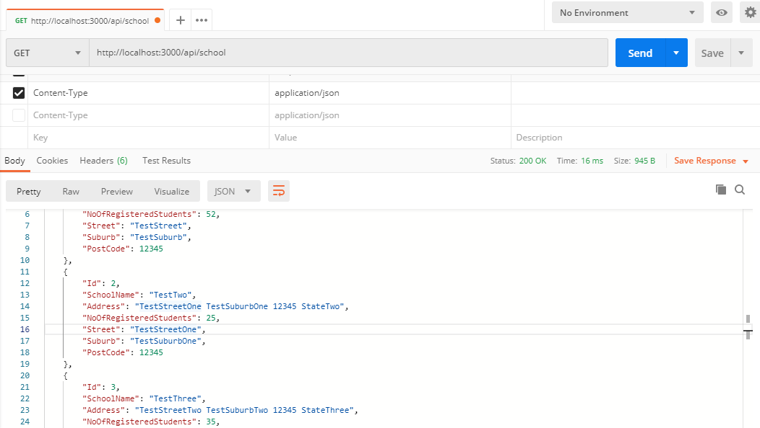

1. With Parameters

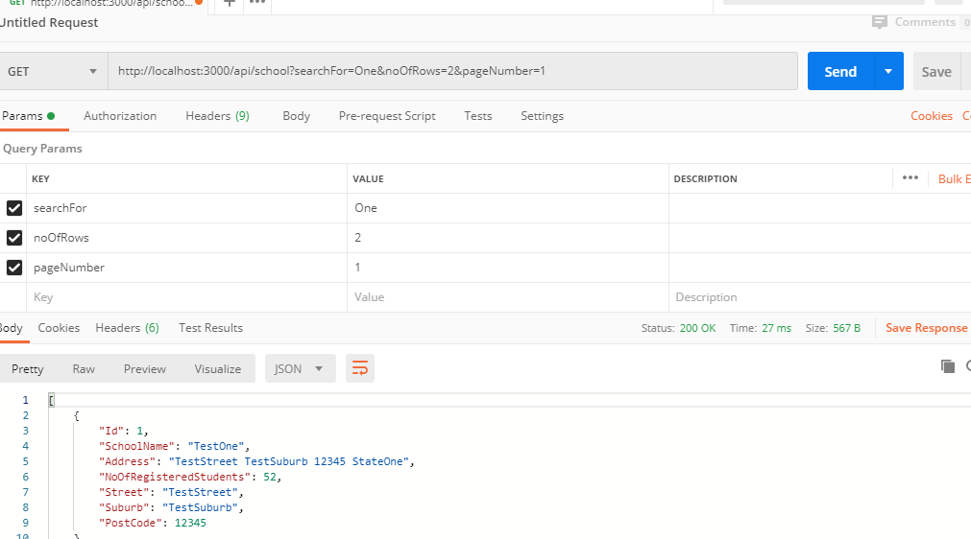

Failure Test Scenario

